需求：**gitlab从A服务器迁移至B服务器**

**第一、在B服务器上部署gitlab环境**

参考《GitLab完整搭建(版本6.3.1)》

**第二、备份A服务器上的数据**

1).打包仓库文件

#su- git

$cd/home/git/

$tarzcvf repositories.tar.gz ./repositories

2).备份sql文件

$mysqldump-uroot -pxxxx gitlabhq_production > /tmp/gitlabhq_production.sql

3).备份keys

$cp/home/git/.ssh/authorized_keys /tmp/authorized_keys

4).复制1-3步的文件到B服务器

$scprepositories.tar.gz gitlabhq_production.sql authorized_keys root@B:/tmp/

**第三、在B服务器上导入数据**

1)**.** 导入仓库,检查权限

$cd/home/git

$tarzxvf repositories.tar.gz

如果权限有异常，直接重新赋权

$chown-R git.git /home/git/repositories/

2).导入数据库

$mysql-uroot -pxxx gitlabhq_production < gitlabhq_production.sql

3).导入keys

$catauthorized_keys >> /home/git/.ssh/authorized_keys

4.将文件导入ruby

$cd/home/git/gitlab/

$bundleexec rake gitlab:import:repos RAILS_ENV=production

$bundleexec rake gitlab:satellites:create RAILS_ENV=production

5).检测

$bundleexec rake gitlab:check RAILS_ENV=production

如果检测没有异常，可以重启gitlab服务

#/etc/init.d/gitlab restart

**第四、验证git pull/push与异常解决**

1)**.** git pull

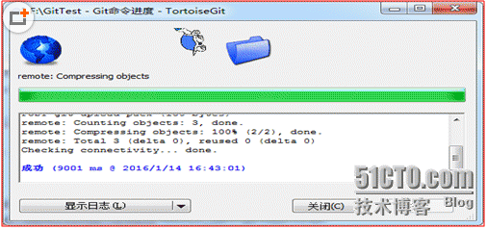

2)**.** git push

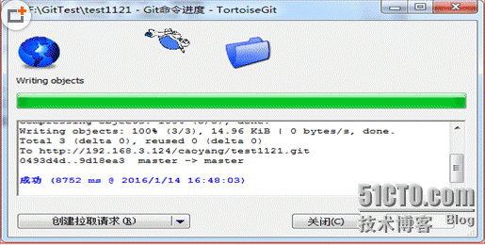

如果报错：

git.exe push --progress "origin"master:master

Counting objects: 3, done.

Delta compression using up to 4 threads.

Compressing objects: 100% (2/2), done.

Writing objects: 100% (3/3), 350 bytes | 0bytes/s, done.

Total 3 (delta 0), reused 0 (delta 0)

remote: GitLab: An unexpected erroroccurred (redis-cli returned 1).

remote: error: hook declined to updaterefs/heads/master

To http://192.168.4.251/caoyang/test1121.git

! [remote rejected] master -> master(hook declined)

error: failed to push some refs to‘http://192.168.4.251/caoyang/test1121.git‘

屏蔽 /home/git/gitlab-shell/config.yml 28行redis配置

